Workshop: Identifying Gaps between HCI, Software Engineering, and Design, and Boundary Objects to Bridge Them

Application of Lisette D. Bakalis, Eelke Folmer and Jan Bosch
Software Engineering & Architecture, University of Groningen, The Netherlands
Contact: L.D.Bakalis@cs.rug.nl

- Background: Your professional position in interdisciplinary teams and a short description of some projects you have worked on.

The Software Engineering & Architecture (SEARCH) group of professor Jan Bosch at the University of Groningen (RUG) has strong interest in usability and software architecture. The SEARCH group is a partner of the European STATUS project, an ESPRIT project (IST-2001-32298) financed by the European Comission in its Information Society Technologies Program, Action Line IV.3. The aim of the STATUS project is to study and determine the connections between software architecture and the usability of the resultant software system. Two members of the SEARCH group, Eelke Folmer and Lisette Bakalis, are financed by the STATUS project.
The SEARCH group is working in close collaboration with the university center for ICT support in education (ECCOO), studying and improving the usability of the university ICT platform on which the university’s website is built.
Lisette Bakalis received her PhD degree in Theoretical Physics at the University of Groningen in 2002. Since then she is working as a manager at ECCOO on ICT projects to facilitate and improve higher education. Here she specialized in usability, from HCI perspective. Lisette organized and supervised usability tests of for instance the university ICT platform on which the university’s website is built, the university website, Blackboard (e-learning) building blocks, home made search engines.
Since september 2003 Lisette combines her work for ECCOO with research at the Software Engineering & Architecture group at the University of Groningen. Her research focuses on usability in software architectures, from software engineering perspectives. The experience of working on both sides of the bridge gives a valuable insight on the gap between HCI and SE, the definition of usabilty and the various boundary objects that bridge the gap.
Eelke Folmer is a PhD student at the Software Engineering & Architecture group. After obtaining a MSc at the University of Groningen, he started to work on his PhD under supervision of Jan Bosch. Eelke's research activities include software architecture assessment & design and software quality (usability).

- Position: Your observations of gaps between disciplines, and the attempts to bridge them with boundary objects or other methods.

We also observe a gap between HCI and SE. To us it appears as a natural aspect of interactive system development. Only when experts of various fields cooperate in a close way, systems can be developed for which all concerns are taken into account. By decoupling the various concerns it becomes possible to decouple the core design from the usability design and thereby reach a higher degree of independence in design.
In software engineering the cooperation of the human oriented HCI experts and the system oriented SE experts are needed to build usable software. It is highly undesirable to combine disciplines and work with a single expert on usability, since humans and systems have opposite goals. We believe that the gap must be present in order to build usable systems.
In order to communicate, the experts must have a certain understanding of each other’s field, therefore they need a common language. The problem is to define what shared knowledge is needed and how to communicate this shared knowledge. The usability expert needs some understanding of what is technically possible, but what exactly does he need to know? The software engineer needs to know what users want in order to build software that is actually going to be used, but what does he need to know, and what not? Any pair of experts who want to communicate need to have some mutual understanding, therefore at least one boundary object should be present.
The definition of the word ‘usability’ is a boundary object on its own. Often ‘usability’ is found to be defined in a small or confined way by addressing to the ease of use of the system. However, ‘usability’ is also affected by for instance ‘security’, ‘maintainability’, ‘performance’ and other attributes. We define ‘usability-small’ as the usability attribute that addresses the direct ease of use, while the ‘usability-broad’ addresses the indirect or global ease of use for the user.
In order to build usable systems, not only SE experts and HCI experts are needed, but also security experts, domain experts and performance experts. Hence we need not only one boundary object to bridge the gap between SE and HCI, but one needs at least six more boundary objects: between the usability expert and the security expert, between the usability expert and the domain expert, between the usability expert and the performance expert. One also needs boundary objects between the SE expert and the security expert, between the SE expert and the domain expert, between the SE expert and the performance expert. The six boundary objects differ.

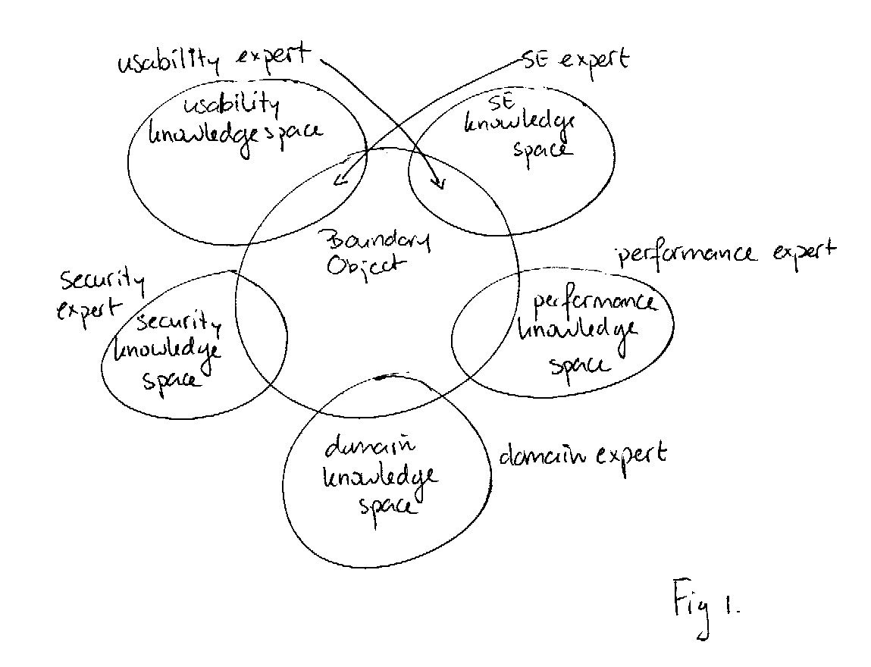

Usability
Engineering
Software
engineering
Usab
Pattern

UP
Securtiy
Pattern/SP

Security engineering

Legenda
UP = usage profile

Op deze manier bestaan er ook unieke boundary objects tussen 2 disciplines.
Het middelste stuk is dan vaak “common domain knowledge/understanding” b.v. het feit dat het over webbased/ E-commerce systems gaat.

Voorbeelden van BO
SE- UE {usage profiles, usability patterns}
SE-SecE {security profile, security patterns)
EU- SecE { usage profiles / security profiles}

Een usage profile zou dan hier als boundary object tussen SE/EU/SecE bestaan.

Figure 1 shows how the boundary objects (BO) define a common concept space, a common language, by which the various experts can communicate.

(3) Sample Materials: a description of a boundary object you have used (if any).

Boundary objects are communication in and across (often geographically) separated teams. Examples of boundary objects are for example usability architecture, reports, email, software code, life cycle and behavior of complex objects defined in test cases, problem reports with test cases demonstrating the problem.

In our contribution, we define two boundary objects which we used to study the webplatform: usability patterns and usage scenario’s.

Architecture sensitive usability patterns: A number of usability patterns have been identified that should be applied during the design of a system’s software architecture, rather than during the detailed design stage. A set of architectural sensitive usability patterns (such as provide multiple views, wizard, undo, multi-channeling etc) have been identified from various cases in industry, modern software, literature surveys as well as from existing (usability) pattern collections.
Example:

Multi-Channeling
Usability context: | - Users want or require (e.g. because of disabilities) access to the system using different types of devices (input/output).  - Increasing the number of potential users (customers) and usage of a system.
Intent: | Provide a mechanism that allows access using different types of devices (input/output).
Architectural implications: | There may need to be a component that monitors how users access the application. Depending on which device is used, the system should make adjustments. For example, by presenting a different navigation menu or by limiting the number of data/images sent to the user.
Usability properties affected: | + Accessibility: this pattern improves system accessibility by users using different devices (accessibility)
Examples: | - Auction sites such as eBay can be accessed from a desktop/laptop, but this information can also be obtained using interactive TV or a mobile phone.  - Some set top boxes allow users to surf the internet using an ordinary TV.  - Some Word processors allow voice input, which allows (disabled) users to control the application by voice.

Usage profiles: A usage profile represents the required usability of the system by means of a set of usage scenarios. A usage scenario is defined as “an interaction (task) between users, the system in a specific context of use”. The usage profile serves as a communication instrument between usability engineers and software architects.These scenarios make it possible to translate the rather abstract usability requirements into specific use cases. This allows architectural assessment; the software architecture may than be evaluated for its support for the scenarios in the scenario profile

Usage scenario:
 | Users | Task | E | L | R | S
1 | End user | Navigate | 3 | 4 | 2 | 1
For example, for the case study we peformed at Webplatform the following usage scenario has been defined: “end user navigating to particular portal”. First, we specified what is understood for each attribute in the context of this task. Then we consulted the usability requirements. For example, a usability requirement that affects this scenario: “navigating the system using the menu bar should be intuitive and self-explanatory”. “The menu bar should be displayed before any pictures”. In this example, terms such as “intuitive” and “self-explanatory” have been associated with learnability. The time it takes to display the menu bar has been associated with efficiency. For this scenario, these requirements have been interpreted by assigning relatively high values to learnability (4) and efficiency (3). The analyst interprets the priority values during the analysis phase to determine the level of support in the software architecture for the usage scenario.
Workshop:
Identifying Gaps between HCI, Software Engineering, and Design, and Boundary
Objects to Bridge Them
Organizers:
Bonnie E. John (HCI Institute, Carnegie Mellon University)
Len Bass and Rick Kazman (Software Engineering Institute, Carnegie Mellon
University)
Eugene Chen (AM+A California)
A useful concept for bridging gaps between disciplines in interactive system development
(e.g., usability engineering, software engineering, visual design, interaction design) is that
of boundary objects. Boundary objects serve each discipline in its own work and also act
as communication devices to coordinate work across disciplines. A“storyboard” can be
considered a boundary object. A designer uses a storyboard to express and explore ideas
in the space of presentation and navigation; a usability analyst uses the same storyboard
to perform an early usability test; a software engineer uses it as part of the specification
of the interface code. The storyboard performs different functions for each discipline, yet
provides common ground for discussing intersecting concerns.
This two-day workshop will collect examples of existing boundary objects, identify
characteristics of boundary objects that successfully span disciplines and those that fail to
do so, identify gaps between disciplines in need of boundary objects, and propose new
boundary objects to bridge those gaps.
Participants will be selected based on their experience bridging gaps between disciplines.
Experiences illuminating the lack, or failure of boundary objects are just as valuable to
this workshop as successful experiences.
Prospective participants are invited to submit a 2-3 page position statement that includes:
(1) Background: Your professional position in interdisciplinary teams and a short
description of some projects you have worked on.
(2) Position: Your observations of gaps between disciplines, and the attempts to bridge
them with boundary objects or other methods.
(3) Sample Materials: a description of a boundary object you have used (if any).
Submit position papers to ljb@sei.cmu.edu.
Important dates: Jan 12, 2004 – position paper due
Feb 23, 2004 – notification of acceptance/rejection
April 25.26 - workshop will be held.

